Peter Victoratos

CSC 411

Lab04 Thresholding

1. Histogram: For this lab I chose a relatively easy image, a Basenji (didn’t even know these existed) over a black background. After converting it to gray I was able to use the histogram to determine the really really low threshold value of 8 for this image. Any lower than that and then the whiskers of the dog become really noisy.

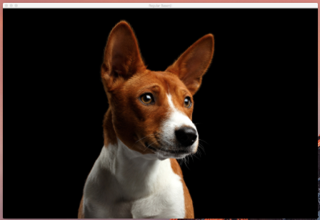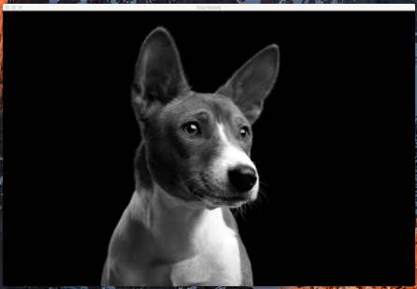

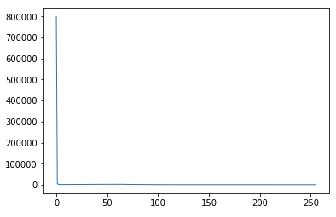

2. Masking: This was the fun part. After creating images including the threshold value, I called the morphological functions to try to make my mask as clean as possible. Initially I used the close function then open, however I ran into trouble with the dog’s nose since it's such a large region of black. So I switched the order of the functions and it seemed to give a smoother mask.

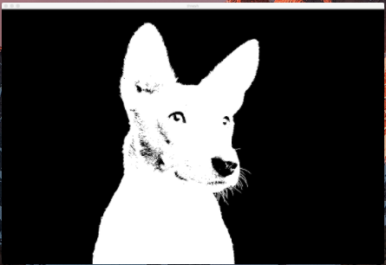

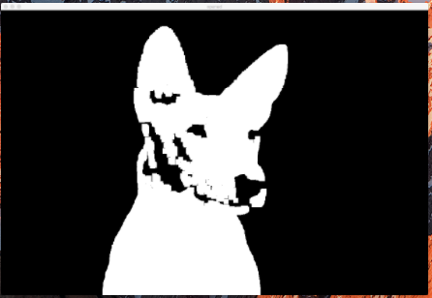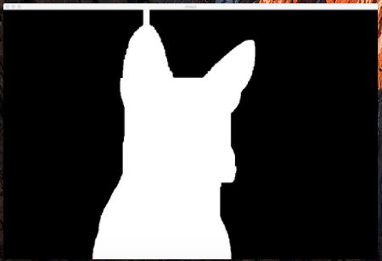

(Opened is to the left and Closed is to the right.) I then took the closed image and made it into a mask to overlay over the original. It is pretty smooth aside from the small amount of clipping near the dog’s snout. This came from the whisker noise. Otherwise, he seems like a pretty cute dog.

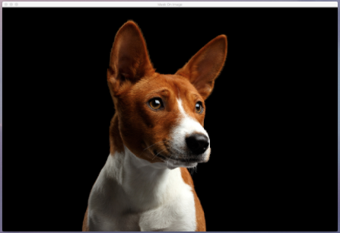

3. Challenge: Greenscreen

I took an image of someone in a green screen suit over a green screen and split the color channels up. By creating a histogram for the green channel I was able to get another threshold value. However this histogram looks the same as the first, so I just entered some random numbers. 223 worked fairly well. I also cleaned up the image with the closed morphological function and then applied it to the original. There is some green that is still there however when I tried to adjust the dimensions of what pixels were edited (in the morphological function), it would create a black box where the little bird is. Then I ran out of time.

